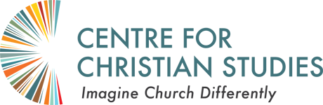
Ages & Stages
Education Learning Circle EW02
Apr 26 to June 2, 2022, Tuesdays and Thursdays
11 am – 2 pm CDT

Apr 26 – Community building
Apr 28 – Intro to Ages & Stages
May 3 – How People Learn and Grow 1
May 5 – How People Learn and Grow 2
May 10 – Ministry with Adults
May 12 – Ministry with Children
May 17 – Ministry with Youth
May 19 – Ministry with Seniors
May 24 – Intergenerational Integration (SL)
May 26 – Diaconal Pedagogy
May 31 – Review of Learnings
Jun 2 – Closure

The Zoom link for this circle is on the CCS Moodle.

